**Week 6 Submission**

**Ameer Karas**

**44948956**

**Question 1**

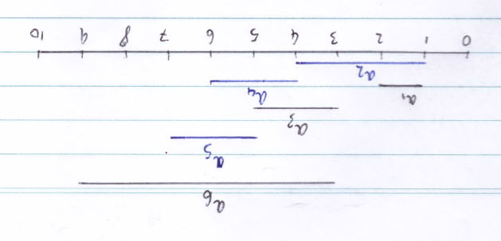

|  |  |  |  |  |  |  |
| --- | --- | --- | --- | --- | --- | --- |
| Activity | 1 | 2 | 3 | 4 | 5 | 6 |
| Start | 1 | 1 | 3 | 4 | 5 | 3 |
| Finish | 2 | 4 | 5 | 6 | 7 | 9 |

I’m using the above table and diagram for part (b).

Suppose we instead choose the last activity to start that is compatible with all previously selected activities.

1. This method is a greedy approach as at each sub-problem, we choose the locally optimal option.
2. From the presented set of activities, we have options within the set S0,10 with which to choose a locally optimal solution. This locally optimal choice is defined as the activity with the latest starting time that is available for choosing (that is to say, it does not overlap with any previously selected activities). At this stage, the greedy choice is a5 which occupies S5,7. The new set of problems to choose from (our set of subproblems) is S0,5. Of this new set, the greedy choice is a3 which occupies S3,5. Our set is now S0,3, of which the only choice, and solution to the last remaining sub-problem, is a1. This results in the maximal set of activities |a1,6|= 3.
3. Let ai,j be the optimal solution for the subproblem Si,j. Suppose that Si,j is the composition of 2 subproblems Si,x and Sx,j and that ai,x  and ax,j are optimal solutions to Si,x and Sx,j respectively. Now assume that there exists a set of maximal activities a’i,x that is a better solution for Si,x. This, however, contradicts our initial assumption that ai,j is the optimal solution for Si,j as ai,j is composed of ai,x  and ax,j, meaning that each solution must also be the optimal solution.
4. I would process the data by sorting the values in descending order of starting times (latest to earliest) to make the problem’s solution easier to visualise. I performed a similar step when drawing the diagram of my example activities.